1. GUI – Should have nicer/better text font
2. GUI – Hero image should be lager to engaging visitor
3. GUI **–** current page layout is not good in the desktop mode, too much spaces in the left and right site, the website will look better if it is designed in full page style.

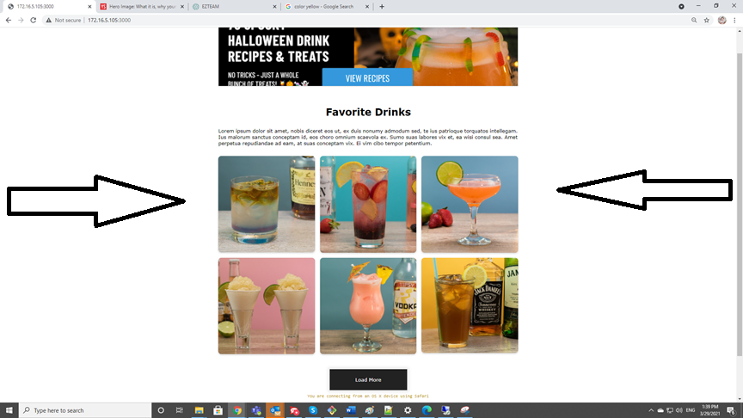

1. **GUI - Bottom of Hero image is cut off**

Browser: Safari 14.3 – Macbook Pro, Chrome 89 – Desktop/Mobile

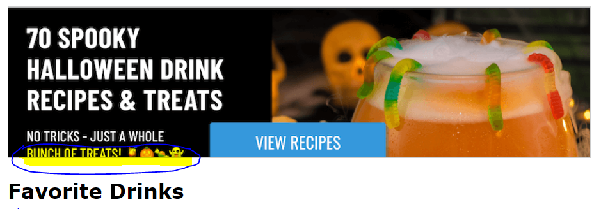

1. **GUI - Button name and footer’s hyperlinks are too small to read**

Browser: Safari 14.3/Chrome 89/ Android 10

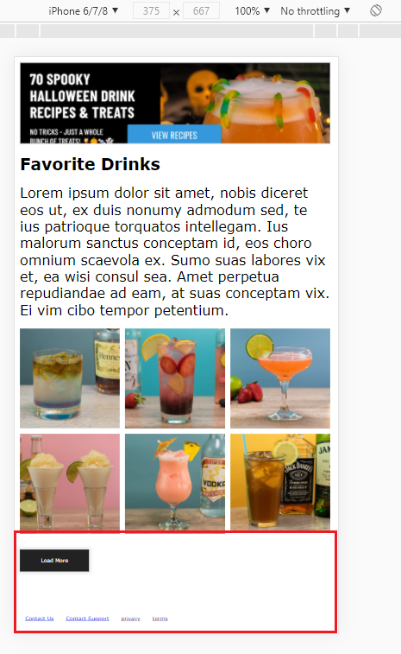

1. **GUI - Text in body is not scaled out if reducing Brower size**

Browser: Safari 14.3 – MacBook Pro, Chrome 89 - Desktop

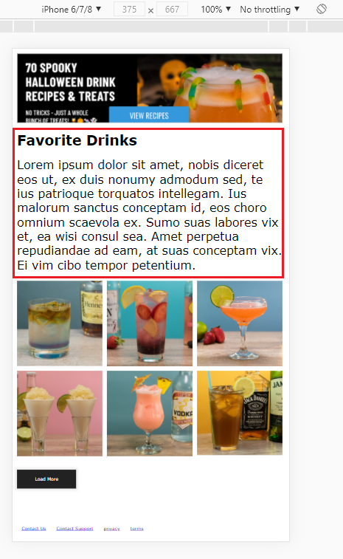

1. **GUI Texts are too small to read**

Test environment:

* Oppo F11 pro - Android 10 – Phone browser (Orientation: Landscape and Portrait)

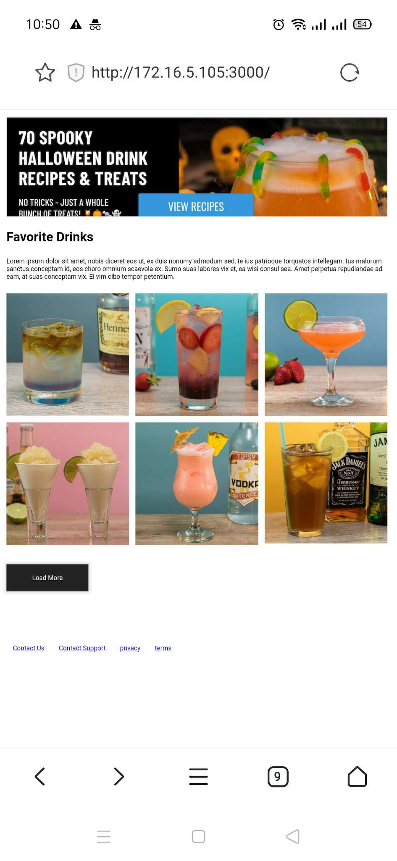 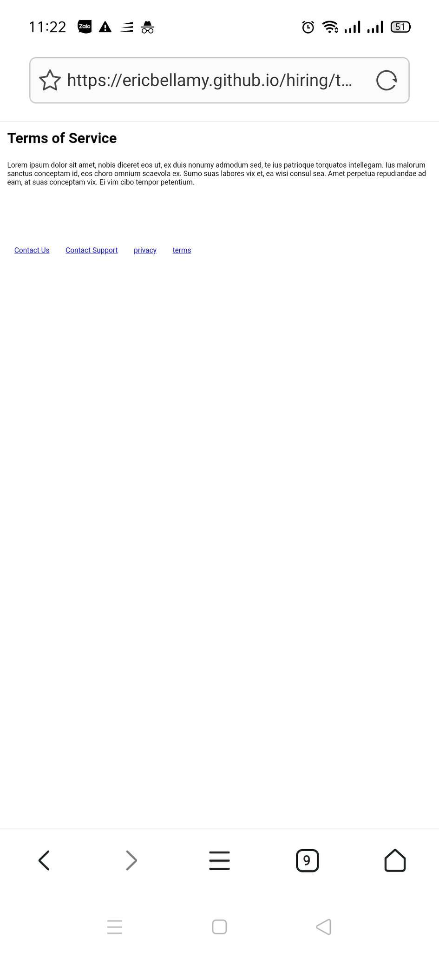 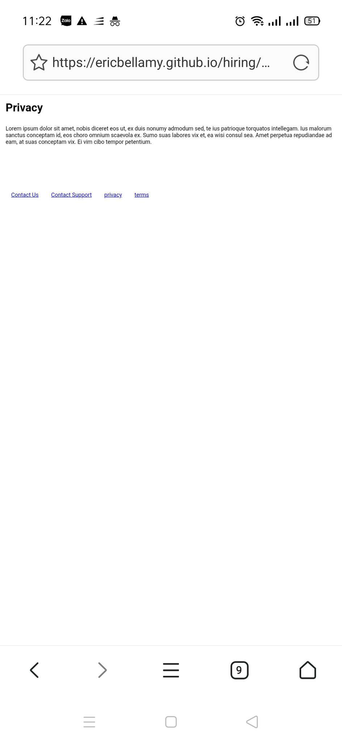

* Iphone 11 – iOS 14.4 –Safari and Chrome 89 (Orientation: Landscape and Portrait)

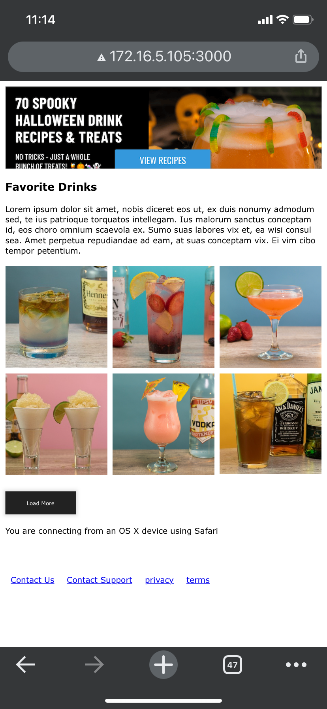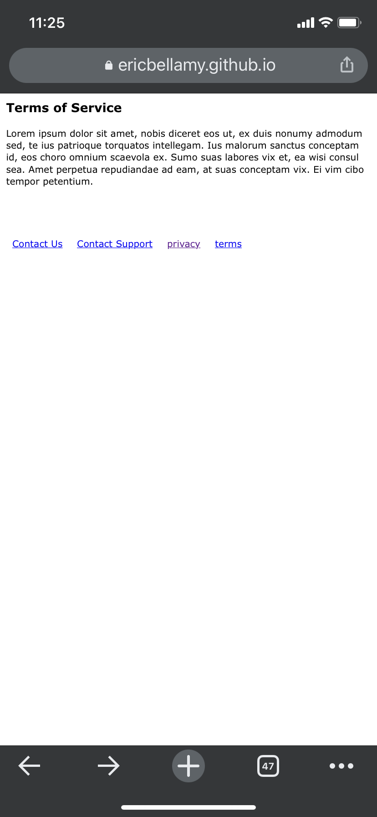

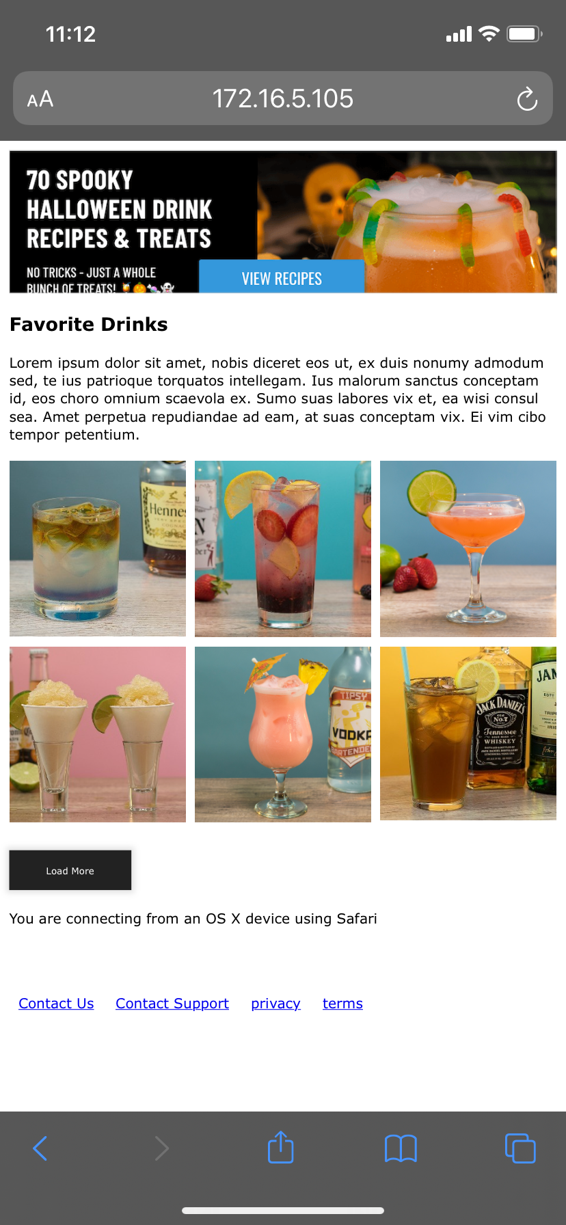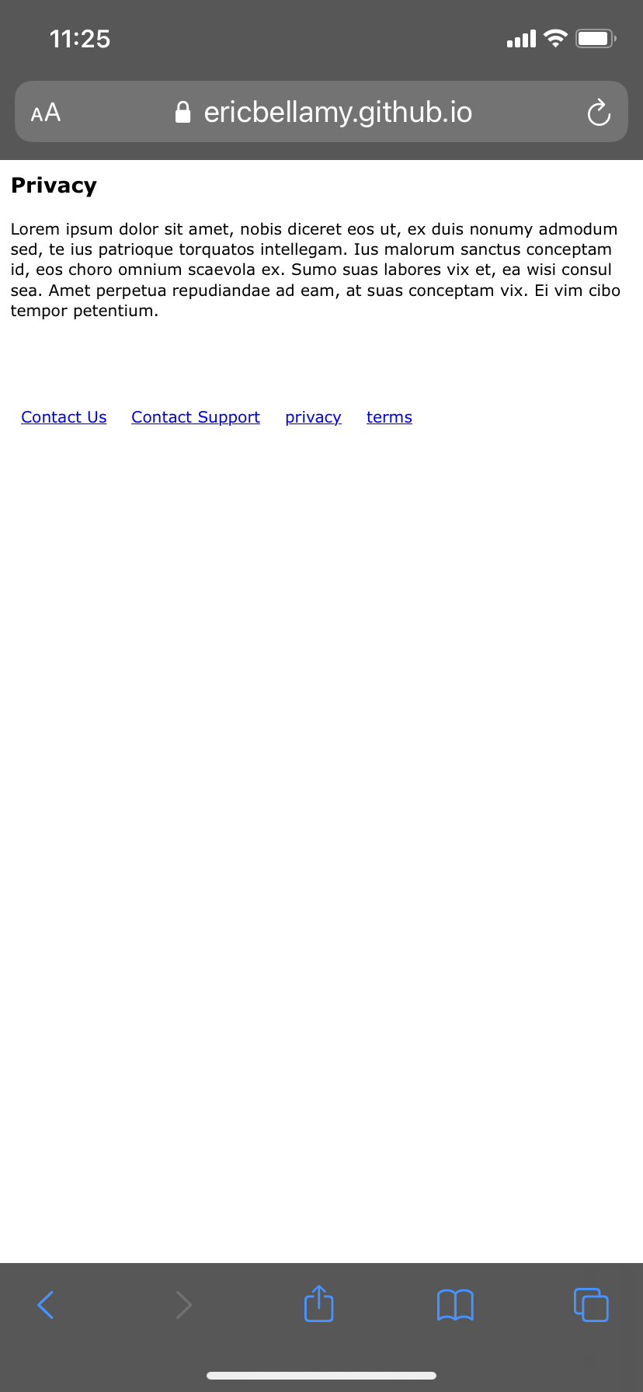

1. **Script error when loading the page on Chrome browser**

Browser: Chrome 89 (only happens on this browser)

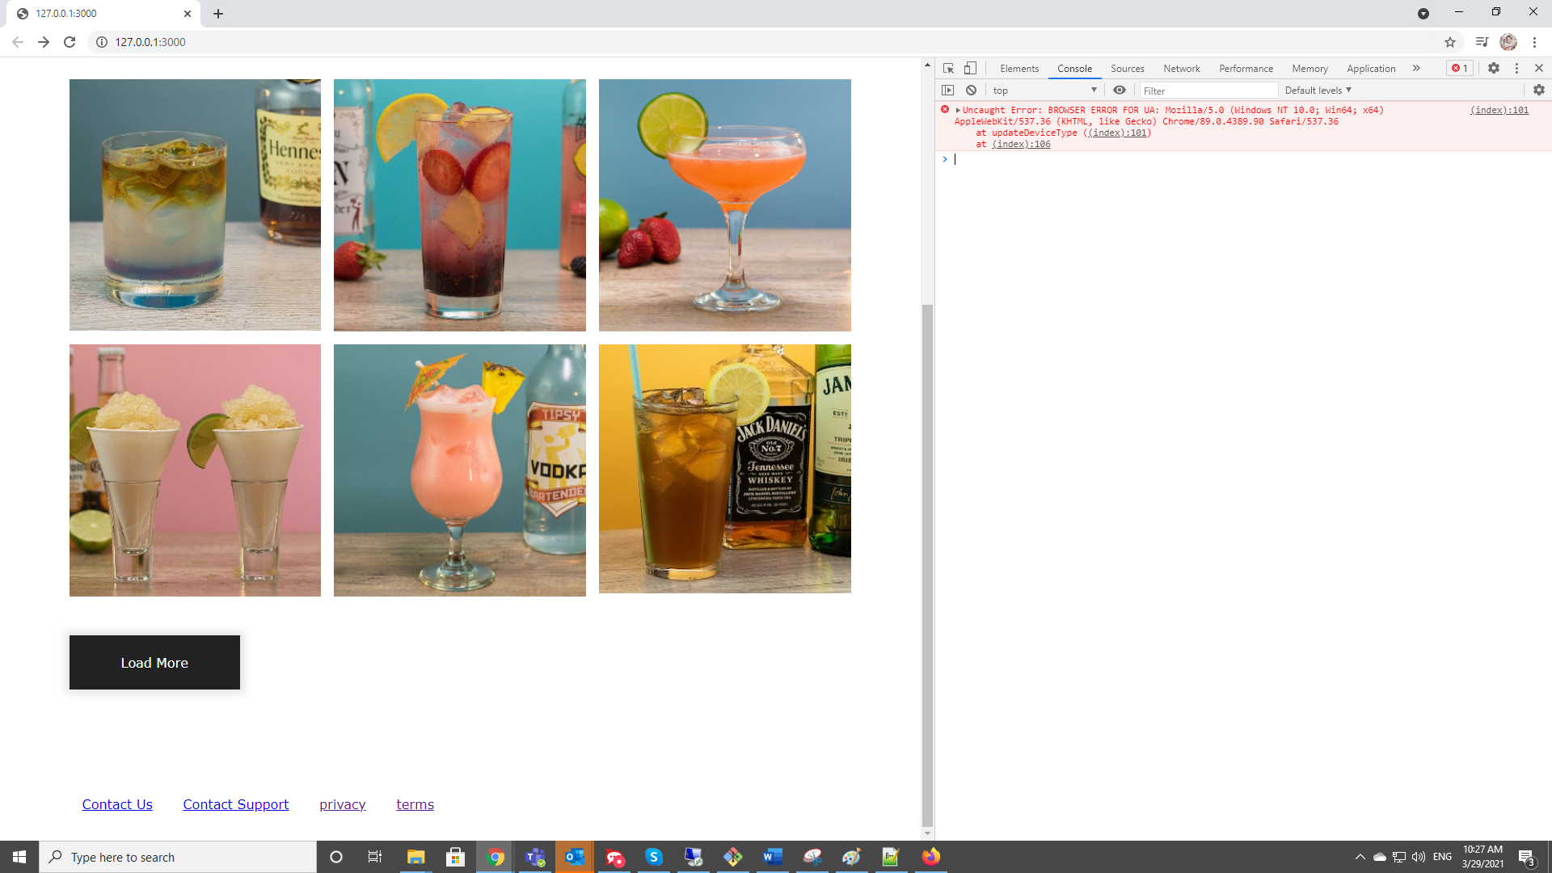

1. “View Recipe” button in the hero image is not functional
2. “Load More” button does not work

Browser: Safari 14.3, Chrome 89, Android 10

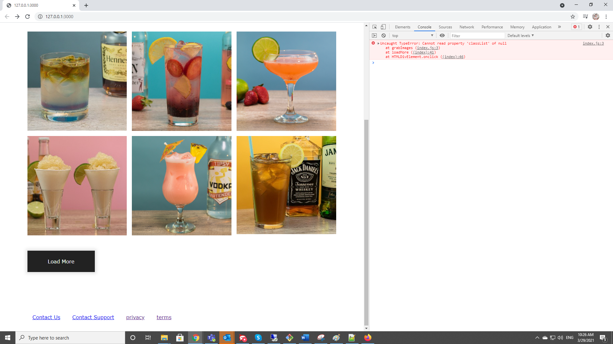

1. As a user I would like to know the details information of a drink, so it is great if clicking on the drink image takes me to the details page for that drink.
2. There is no way to go back the page from Privacy and Terms pages, there should be a navigator to go back or menu to navigate between pages.
3. Should apply CSS for text and buttons to have better look

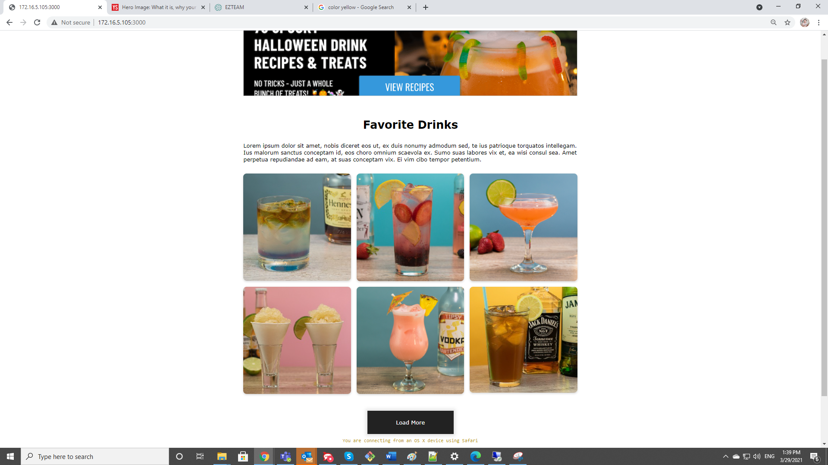

1. <https://www.loom.com/share/c5a3874380f84929af34ad548201917b>